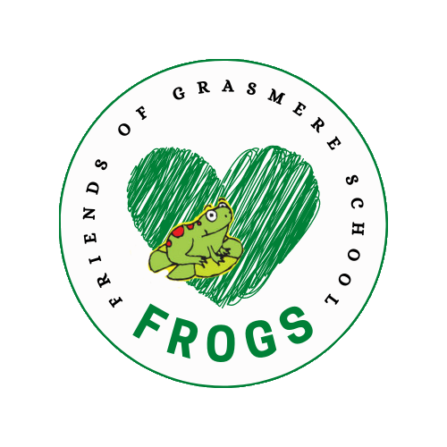

FROGS MEETING
WEDNESDAY 13 MARCH ZOOM

1. FINANCIAL UPDATE & ADMIN

> Recent spends: Yoga workshops (mental health); Mud kitchen & trugs (garden project);
Hall curtains (£3,500); around £900 Kapla workshop (whole school treat); Happy Squares workshop £600 (science week), World Book Day £400; voted via Whatsapp.
> Pub quiz: Fundraised £850
> Cake Sale Class Treats update
> Google Enterprise. Magnus and Rob to set it up before next school year.
> Cooking supplies waiting for Barley to order equipment and for invoice (around £830)

School has said they would cover the costs of extra time to maintain the library so FROGS doesn’t need to fund this. Léa to handover information to member of staff.

2. CURRENT PROJECTS

> Hall Refurb Curtains ordered and being installed. Waiting for mural artwork. (Jenny) Waiting for cost of AV equipment (David S)
> Garden Project Mud kitchens & trugs in place (William to move one element). Sensory maze to plant and built. Children have voted on their favourite equipment. Climbing equipment costs and options to be considered.
> Reading room Wallpaper wall (David H). Buy seat cushions and Read Write Inc storage (Léa & Emmy). Source new table and chairs (Neela).
> Basketball hoop waiting to hear how to receive the money. Checking options with school. Looking into various option for new hoops/football goal (David S)
> FROGS banner for kids to take pictures of in front on first day of school every year.
* VOLUNTEER NEEDED to get quotes for cost of banner and stand.

3. EVENTS

> Saturday 16 March: Jumble sale (Léa & Jay). BHF in Dalston to pick up leftovers following week. Hackney Baby Bank also contacted. Books (Adriana)
> Wednesday 27 March: Easter Egg hunt (Jay & Nicola, Gill supermarket donations)

Summer term
> Painting, planting and cleaning days in the spring
(using litter pickers we have bought for the school and the paint we already have)
> Chess event (Ruth) Parent Olympic chess champion offered to do tournament to raise money to buy outdoor chess set. Giant chess set 3x3m costs around £350. Could paint the chess board – check where it would fit perhaps on the pavement in the garden or by the old library wall? Storage for the pieces? 2 black 340l grit/salt storage bins (£170 each) Would need to raise around £700.
> International day TBC usually organised by school. TBC. A day where kids bring bread from their own country to class, and free picnic after school. Would be after Ramadan.
> June: Enterprise fair 14th June TBC * VOLUNTEER ORGANISER NEEDED
Dolly offered to cook dahl and other treats for takeaway.
> July: Summer fair 13th June (Megan & Sally)
> July: End of year Mr Bubbles (to book, around £400?)

4. FUNDRAISERS & GRANTS RESEARCH

> Funded research We’ve a list of grants we could potentially apply for from Funded.
* VOLUNTEER needed to go through them and check which we can apply to. There are usually lots of restriction for schools including number of free-school meal children, or access to spaces by the general public.
> Solar panels and eco-efficiency Waiting for an advisor from Let’s Go Zero to undertake a feasibility study in April. Apply to Hackney Community Energy Fund at the end of this year. Retrofit Action for Tomorrow to advice on other funding options. (Nat and Matt, Neela)
> Ironmonger’s charity grant to transform railing in front of Patsy’s office (Barley, Emilie)
> Tesco tokens scheme We can reapply at the end of the school year. Perhaps for the kitchen? To upgrade some equipment etc? It has to be about health/sport etc.

5. OTHER IDEAS
Suggested to school:
- Dog workshops
- Jamie Oliver school food competition
- Simone has offered to help train kids to produce a dance show
- Georgie can help organise concerts through her world music charity
- Google volunteers: school TC

5. NEXT YEAR’S PROJECTS

Fundraiser ideas:
- Need volunteer organisers for our big events: October/March: Jumble Sale; September: Garden Party (with kids?), November: Disco, December: Winter Fair, January: Cinema Night, February: Pub Quiz; March/April: Easter Egg Hunt; June: Entreprise Fair; July: Summer Fair.
- Grasmere cookbook & Grasmere tea towels (Léa)
- Silent auction or Rainbow raffle in the spring?

Albion Road Front Entrance// Old library wall murals/stairs/Makerspace/Music Room/Blue Container. Waiting for school update
7. DATE OF NEXT MEETING TBC

