FROGS MEETING
WEDNESDAY 15 NOVEMBER 2023
ONLINE

1. FINANCIAL UPDATE & ADMIN

> Recent spends: Disco financials & feedback. Bulbs for the school gardens and planters – ordered £230 worth of soil, bulbs and grit. Sharon & Barley to plant bulbs with the children.

> Reserves policy. Charity Commission guidance requires us to have a reserves policy setting out how much money we will hold in reserve at any one time and why. Historically, we have held about one year's spending in cash, which is arguably too much. To be discussed with a view to adopting a formal policy at the next meeting.

> Savings account. Our cash reserves are currently held in an account that pays ~0% interest. Magnus would like the committee to consider resolving that he should be allowed to open new savings accounts to shop for better rates.

> Google Enterprise. We have been granted free access to Google Enterprise for Charities. What is best way to make use before Magnus finalises setup? Shared email.

> School to send invoices for the following:
Cake sale class treats. So far this year: Year 6: £200 + £198 rounded up to £200 – towards Globe Theatre visit, which costs £550. Year 5: £115 + £229 – towards IMAX screen £10 per child, costs £220+ (so they'll have leftover money for board games books etc). Year 2+3+4: at least £400 – towards a Beach trip cost TBC, depends also if they did go to SWAPA last year (not been invoiced?). Year 1: at least £400 – towards a ZooLab visit £249. Rec/Nursery: at least £200 – TBC. Any leftover treat money could be used to buy board games etc for wet play or books or other equipment for their classrooms.
Nursery Reception Refurb – £3,000 invoice to come
Flipcharts: not ordered yet invoice to come shortly
Blinds for kitchen & art room using remainder of fan fundraiser money – invoice to come
Cost of Little Angel & Panto trips funding tickets for those who can’t afford them if needed; amount TBC. We have £400 set aside for this (2021 treat money that hasn’t been used). If not needed we can put it back in main FROGS pot.

> Hardship fund school to confirm how much is left if anything. Plan is not to do hardship fund again but to focus on food bank and help for specific trips/clubs etc.

2. VOTING ON SPENDS

> Cooking supplies list from Barley from Ikea £830. No luck with other suppliers such as Nisbet. Other option is hob by VonShef on Amazon/B&Q. Asked Barley if ok.
> 5-11 Februrary Children’s mental health week Approved by school. Yoga/wellbeing workshops (Nat)Yoga on the Lane workshops for all years including nursery would cost £320. Yoga Mats?

> 5+ litter pickers Neela keen to have those for the kids to clean up playgrounds/garden.
Pack of 8 on amazon costs £24

> Hiding the storage area & installing divider curtain so hall can be used by after-school club and enrichment clubs at the same time for example (Léa). Quotes:
The Curtain and Blind Company Limited: both curtains £3,300 (plus VAT);
Continental: only the main curtain: £3,655.42 (plus VAT)
Custom Group Limited: waiting for quote
Edwards Sports: waiting for quote

3. WOODLAND PLAY AREA PROJECT
We now have a Whatsapp group of garden/greening up Grasmere volunteers.
Woodland play area with platforms around trunks; climbing; lots of space to run around, with a loose part play element (den building etc) and an amazing mud kitchen. Three different quotes for our £30,000 budget. M
Made from Scratch: £32,000 (including £2,000 for kids design/workshop, see price list)
Sovereign Play: £30,000 (see proposal), can be tweaked to smaller amount/less equipment
Final quote to come:
Should we move money from FROGS savings to the play area project? Or wait?
(move garden party proceeds to Kindlink garden project pot)

4. FUNDRAISERS & GRANTS RESEARCH
Current fundraisers:
- Christmas Cards. Should be with parents now. Order before 20th November (Jenny)
- Made-to-order Grasmere tops (Veronika ordered last week)
- Art club: probably raise about £1,000 after expenses (Léa & Adriana)
- Tesco token fundraiser for outdoor sports equipment (Léa).
We can reapply at the end of the school year to the same Stronger start thing.

Fundraiser ideas to raise money for big project:
- Silent auction?
- Rainbow raffle?
- Grasmere cookbook
- Grasmere tea towels

Funded From governors, we’ve paid for £180 for help to find grants from the Funded team.
Focus: upgrading the tech for whole school ie Chromebooks (Shannon, Siobhan) ; kitchen upgrade; adaptive technology/teaching resources for SEND (Neela/Debbie). Acoustic panels for the hall.

Groundwork Our Space award deadline 15 December
https://www.groundwork.org.uk/london/our-space-award/
Plant trees in KS1, dig up around tree in KS2, green up everywhere (including green roofs for toilet blocks, hide bins, ivy screen, and plant native species etc in the garden to complement the play elements. Hackney street specialist has given advice on which trees to plant in KS1
Other option: https://ngs.org.uk/who-we-are/community-garden-grants/

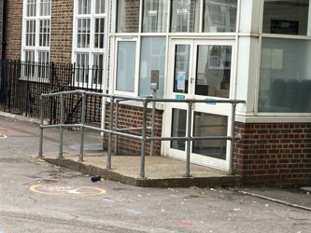
> Ironmonger’s charity grant deadline March 2024.
Does anyone know a blacksmith who could work with the children on a design for this fence? The grant would fund this type of project.

5. OTHER PROJECTS

> Banners and signs from Albion Road entrance. School looking into banners & will confirm cost. School also keen on big metal letters with name of school – can someone get quotes for this: GRASMERE SCHOOL, to be added to the top of the brick wall.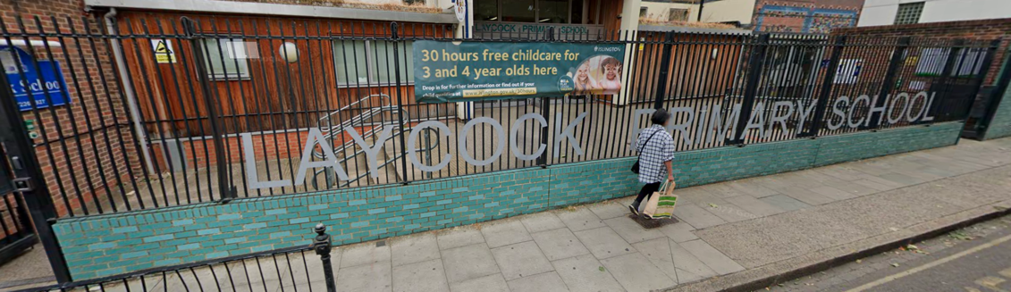

> Fruits for KS2 Following trial school says not needed. Ruth has applied to Streetbox.
> Wall in the Hall mural: Artist Toby Marsh as kindly agreed to help design/paint a mural. Kids artworks (from school & art club) with artist. (Jenny)
> Acoustic panels to be installed on ceiling to change the atmosphere of the hall. It would transform lunchtimes etc. School keen to do this; longer-term project as likely to be a big amount; might be grants for it. (David)
> FROGS banner for kids to take pictures of in front. Need to get cost of banner and stand.
> KS2 Wall painting- Megan will coordinate volunteers on a Friday or Saturday. Veronika to check paint colours. Need to buy paint etc.

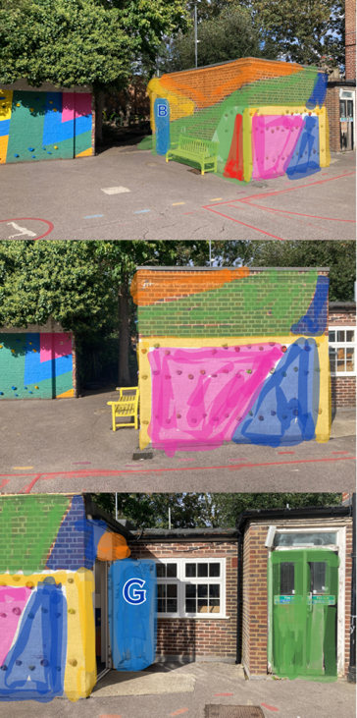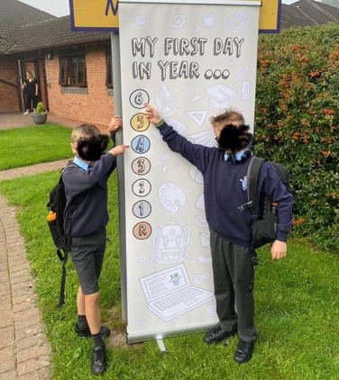

> Reading room -Quiet space on first floor just above library. Needs decorating to make it cosy (volunteers needed) plus new cushions for Ikea armchairs. To complete for World Book Day in March? - Lea to catch up with Emmy to check what needs doing

3. EVENTS

Friday 8 December: Winter Fair – no organiser this year so each class is responsible for setting ordering in advance etc etc. Might need to scale it back next year if no one volunteers to take over. Licence from Council re mulled wine. 12 Days of Christmas sing all together to kickstart the fair (Emmy). 2 staff members volunteering.

SPRING TERM
Friday 26 January: Cinema night (Caroline, Nicola)
5-11 Feburary Children’s mental health week Yoga/wellbeing workshops (Nat, Debbie)
Tuesday 27 February: Pub quiz for parents (Andrew, Karen, Nicky, Nicola)
7 March World Book Day Author visit TBC. Bookmark Workshop? Hogwarts fair? (Emmy)
10-19 March - Science Week Have emailed Jess the science lead regarding Kaplaclubs (costs £5 per child and involve each class building a giant Kapla construction in the main school hall), Happy Square and Stem ambassador, waiting to hear back
Saturday 16 March: Jumble sale (Lea & Jay). Check with BHF new shop in Dalston if they could pick up leftovers.
Wednesday 27 March: Easter Egg hunt (Jay & Nicola, Gill supermarket donations?)

SUMMER TERM
Volunteer days
Possibly International day, usually organised by school. TBC. A day where kids bring bread from their own country to class, and feast/picnic after school. Would be after Ramadan too.
Taskmaster style/sporty event TBC School is taking part in hackney move half marathon and bike ride. (VOLUNTEER ORGANISER NEEDED)
May: Circus or Beatbox workshops after the exams?
June: Enterprise fair 14th June (VOLUNTEER ORGANISER NEEDED)
July: Summer fair 13th June (Megan & Sally) & End of year Mr Bubbles

6. OTHER IDEAS/FEEDBACK/QUERIES
Renting out the school: parent can rent out hall/garden for birthdays etc via the office. Plan is to have the school on a website such as Sharesy.
Timetable Rockstars: school is still using this please check with office for logins etc
Parents sharing their skills: Simone has offered to help train kids to produce a dance show but there’s no space to hold rehearsal at lunchtime or breakfast time until we install a divider curtain in the hall. Georgie can help organise concerts through her world music charity, she’s offered to organise some oud/Arabic music workshops by Palestinian artist Saied Silbak which would cost around £300 for whole school, cheaper if just an assembly (asked Emmy)
Competitions: School to let us know if there’s any they would like to enter.
> Enrichment Club / Library help Offered to pay someone (staff or parent) a few hours each term to help manage the enrichment clubs or library. School says not needed at the moment
> Google volunteers: School chasing this
> Makerspace/ Blue container/ Old library wall murals/stairs
We would love to help create a makerspace with more room for design and technology equipment and construction toys. Help turn the blue container in a quiet space etc or outdoor classroom; games/books/white screen? Floor cushions? Need new picnic tables?
Paused until we learn more about ownership of building and front garden and grants

7. DATE OF NEXT MEETING TBC February?

