FROGS MEETING
WEDNESDAY 15 NOVEMBER 2023
8PM ONLINE

Attendees:
Léa (chair), Magnus (treasurer), Caroline (secretary), Rob (year 3 and 1), Roz (year 3 and 1), Karin (woodland play area), Jay (committee member)

1. FINANCIAL UPDATE & ADMIN

> Recent spends:
Disco good feedback for early years – should do the separate session again. Longer DJ hour or music only – perception was generally very positive. Kids liked it a lot
Bulbs for the school gardens and planters – ordered £230 worth of soil, bulbs and grit. Sharon & Barley to plant bulbs with the children.

> Reserves policy. Charity Commission guidance requires us to have a reserves policy setting out how much money we will hold in reserve at any one time and why. Historically, we have held about one year's spending in cash, which is arguably too much. To be discussed with a view to adopting a formal policy at the next meeting.
- Discussion on how much we could keep. Perhaps 10% of the annual turnover? Can think about what to hold and discuss at future meetings.

> Savings account. Our cash reserves are currently held in an account that pays ~0% interest. Magnus would like the committee to consider resolving that he should be allowed to open new savings accounts to shop for better rates - no too high interest rates available for charities, could look at 1-2% savings account but not really worth it.

> Google Enterprise. We have been granted free access to Google Enterprise for Charities. What is best way to make use before Magnus finalises setup? Shared email.
- Magnus and Rob will block out some time to set it up

> School to send invoices for the following:
Cake sale class treats. So far this year: Year 6: £200 + £198 rounded up to £200 – towards Globe Theatre visit, which costs £550. Year 5: £115 + £229 – towards IMAX screen £10 per child, costs £220+ (so they'll have leftover money for board games books etc). Year 2+3+4: at least £400 – towards a Beach trip cost TBC, depends also if they did go to SWAPA last year (not been invoiced?). Year 1: at least £400 – towards a ZooLab visit £249. Rec/Nursery: at least £200 – TBC. Any leftover treat money could be used to buy board games etc for wet play or books or other equipment for their classrooms.
Nursery Reception Refurb – £3,000 invoice to come; Léa to take pictures of new stuff.
Flipcharts: Not ordered yet, Emmy doing, invoice to come shortly.
Blinds for kitchen & art room using remainder of fan fundraiser money – invoice to come
Cost of Little Angel & Panto trips funding tickets for those who can’t afford them if needed; amount TBC. We have £400 set aside for this (2021 treat money that hasn’t been used). If not needed we can put it back in main FROGS pot.

> Hardship fund school to confirm how much is left if anything. Plan is not to do hardship fund again but to focus on food bank and help for specific trips/clubs etc.- all ok with this

2. VOTING ON SPENDS

> Cooking supplies list from Barley from Ikea £830. No luck with other suppliers such as Nisbet. Other option is hob by VonShef on Amazon/B&Q. Asked Barley if ok.
Voted Barley can choose which one she wants and we are ok to fund
> 5-11 February Children’s mental health week Approved by school. Yoga/wellbeing workshops (Nat)Yoga on the Lane workshops for all years including nursery would cost £320. Yoga Mats? Might be able to just use gym mats. All ok with this spend

> 5+ litter pickers Neela keen to have those for the kids to clean up playgrounds/garden.
Pack of 8 on amazon costs £24 All ok with this spend

> Hiding the storage area & installing divider curtain so hall can be used by after-school club and enrichment clubs at the same time for example (Léa). Quotes:
The Curtain and Blind Company Limited: both curtains £3,300 (plus VAT);
Continental: only the main curtain: £3,655.42 (plus VAT)
Custom Group Limited: waiting for quote
- Everyone is very keen on this idea as it would help use the space in multiple ways at the same time. Details of the quotes need to be checked (Lea)

3. WOODLAND PLAY AREA PROJECT
We now have a Whatsapp group of garden/greening up Grasmere volunteers.
Woodland play area with platforms around trunks; climbing; lots of space to run around, with a loose part play element (den building etc) and an amazing mud kitchen. Three different quotes for our £30,000 budget (Karin)
Made from Scratch: £32,000 (including £2,000 for kids design/workshop, see price list)
Sovereign Play: £30,000 (see proposal), can be tweaked to smaller amount/less equipment
Touchwood: final quote to come. – do only bespoke projects
Should we move money from FROGS savings to the play area project? Or wait?
(move garden party proceeds to Kindlink garden project pot)
- we need to decide how much money we ultimately want and can spend on it.
- £ 30k seems a high figure to raise without funds, so we might need to split it up and start with smaller projects in the meantime – mud kitchen for example is a basic we want to install
- FROGS could put £ 10k from their reserves in to be matched by donations hopefully
- Then we need to check how much can we get for options of £10K, £15k and £20k

4. FUNDRAISERS & GRANTS RESEARCH
Current fundraisers:
- Christmas Cards. Should be with parents now. Order before 20th November (Jenny)
- Made-to-order Grasmere tops (Veronika ordered last week)
- Art club: probably raise about £1,000 after expenses (Léa & Adriana)
- Tesco token fundraiser for outdoor sports equipment (Léa).
We can reapply at the end of the school year to the same Stronger start thing.

Fundraiser ideas to raise money for big project:
- Silent auction?
- Rainbow raffle?
- Grasmere cookbook
- Grasmere tea towels
All TBA depending on volunteers

Funded From governors, we’ve paid for £180 for help to find grants from the Funded team.
Focus: upgrading the tech for whole school ie Chromebooks (Shannon, Siobhan) ; kitchen upgrade; adaptive technology/teaching resources for SEND (Neela/Debbie). Acoustic panels for the hall.
- Rob will look into it, he’ll get specs of what’s needed and see what he can find

Groundwork Our Space award deadline 15 December
https://www.groundwork.org.uk/london/our-space-award/
Plant trees in KS1, dig up around tree in KS2, green up everywhere (including green roofs for toilet blocks, hide bins, ivy screen, and plant native species etc in the garden to complement the play elements. Hackney street specialist has given advice on which trees to plant in KS1
Léa and Ruthie applying for this grant, getting quote from Ruskins to plant trees.
Other option: https://ngs.org.uk/who-we-are/community-garden-grants/

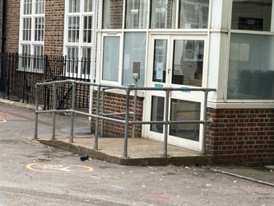
> Ironmonger’s charity grant deadline March 2024.
Does anyone know a blacksmith who could work with the children on a design for this fence? The grant would fund this type of project.
-If so, please let Frogs know.

5. OTHER PROJECTS

> Banners and signs from Albion Road entrance. School looking into banners & will confirm cost. School also keen on big metal letters with name of school – can someone get quotes for this: GRASMERE SCHOOL, to be added to the top of the brick wall. - tba

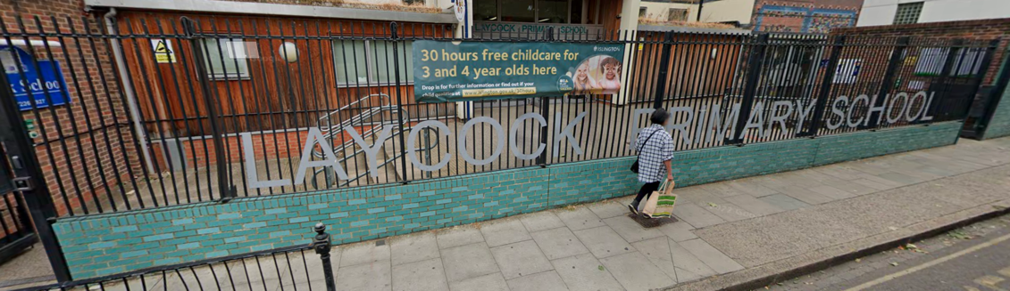

> Fruits for KS2 Following trial school says not needed. Ruth has applied to Streetbox but they don’t really have a scheme at the moment.
> Wall in the Hall mural: Artist Toby Marsh as kindly agreed to help design/paint a mural. Kids artworks (from school & art club) with artist. (Jenny)
> Acoustic panels to be installed on ceiling to change the atmosphere of the hall. It would transform lunchtimes etc. School keen to do this; longer-term project as likely to be a big amount; might be grants for it. (David)
- David gave us quotes but needs to be discussed as it’s a high expense
- can we get grants for this project? Tba

> FROGS banner for kids to take pictures of in front on first day of school every year.
Need to get cost of banner and stand. - tba
> KS2 Wall painting- Megan will coordinate volunteers on a Friday or Saturday. Veronika to check paint colours. Need to buy paint etc. Sketch below of how it could look:

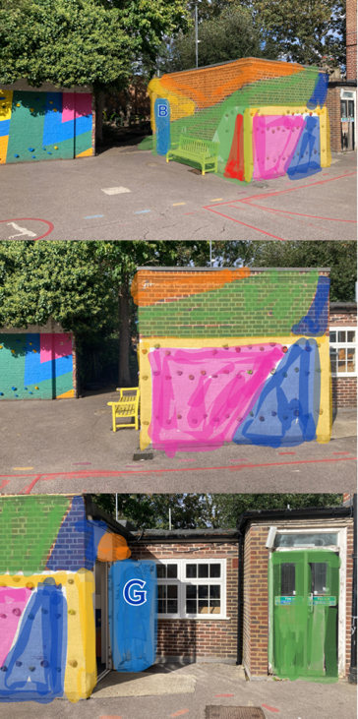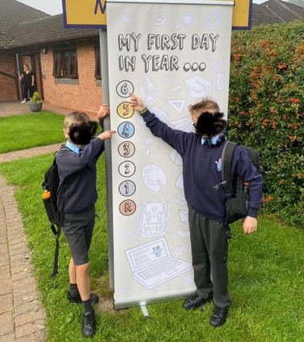

> Reading room -Quiet space on first floor just above library. Needs decorating to make it cosy (volunteers needed) plus new cushions for Ikea armchairs. To complete for World Book Day in March? (Lea waiting for Emmy to get back) TBA

3. EVENTS

Friday 8 December: Winter Fair – no organiser this year so each class is responsible for setting ordering in advance etc etc. Might need to scale it back next year if no new volunteers to take over. Licence from Council re mulled wine (Magnus). 12 Days of Christmas sing all together to kickstart the fair (Emmy). 2 staff members volunteering. Not many volunteers have signed up yet. Santa & Elves confirmed
- Need more volunteers – reminders have and will be sent out if more needed
- Each year group is responsible to organise their stalls. Reps to be in charge.

SPRING TERM
Friday 26 January: Cinema night (Caroline, Nicola)
5-11 February Children’s mental health week Yoga/wellbeing workshops (Nat, Debbie)
Tuesday 27 February: Pub quiz for parents (Andrew, Karen, Nicky, Nicola)
7 March World Book Day Author visit TBC. Bookmark Workshop? Hogwarts fair? (Emmy)
10-19 March - Science Week Lea has emailed Jess the science lead regarding Kaplaclubs (costs £5 per child and involve each class building a giant Kapla construction in the main school hall), Happy Square and Stem ambassador (waiting to hear back from Jess)
Saturday 16 March: Jumble sale (Lea & Jay). Check with BHF new shop in Dalston if they could pick up leftovers (Jay) & Hackney Baby Bank. Can do books with app as usual. Separate clothes collection booked but can be cancelled. Did we get paid for last one?
Wednesday 27 March: Easter Egg hunt (Jay & Nicola, Gill supermarket donations?)

SUMMER TERM
Volunteer days for painting and building mud kitchen TBC
Possibly International day, usually organised by school. TBC. A day where kids bring bread from their own country to class, and free picnic after school. Would be after Ramadan too.
Taskmaster style/sporty event TBC Something sporty & fun but perhaps not run/bike as school is taking part in hackney move half marathon and bike ride. (VOLUNTEER ORGANISER NEEDED)
May: Circus/Beatbox workshops after the exams? (Lea/Nicola)
June: Enterprise fair 14th June (VOLUNTEER ORGANISER NEEDED)
July: Summer fair 13th June (Megan & Sally) & End of year Mr Bubbles

6. OTHER IDEAS/FEEDBACK/QUERIES
Renting out the school: parent can rent out hall/garden for birthdays etc via the office. Plan is to have the school on a website such as Sharesy.
Timetable Rockstars: school is still using this please check with office for logins etc
Parents sharing their skills:
- Simone has offered to help train kids to produce a dance show but there’s no space to hold rehearsal at lunchtime or breakfast time until we install a divider curtain in the hall.
- Georgie can help organise concerts through her world music charity, she’s offered to organise some oud/Arabic music workshops by Palestinian artist Saied Silbak which would cost around £300 for whole school, cheaper if just an assembly (have asked Emmy)
Competitions: School to let us know if there’s any they would like to enter.
Enrichment Club / Library help Offered to pay someone (staff or parent) a few hours each term to help manage the enrichment clubs or library. School says not needed at the moment
Google volunteers: School chasing this – bc of safeguarding school needs to organise rather than FROGS. They are also asking them about computers etc.
Makerspace/ Blue container/ Old library wall murals/stairs
We would love to help create a makerspace with more room for design and technology equipment and construction toys. Help turn the blue container in a quiet space etc or outdoor classroom; games/books/white screen? Floor cushions? Need new picnic tables?
Paused until we learn more about ownership of building and front garden and grants.

7. DATE OF NEXT MEETING 19th January 2024 at 9am

