FROGS MEETING
WEDNESDAY 19 APRIL 2023
8PM ZOOM

Lea (chair), Erla (year 2 and 5), Nicola (treasurer), Nicola (year 3 and 6) , Magnus (reception and nursery), Veronika (year 3), Caroline (secretary), Gill (year 3), Jay (reception)

1. FINANCIAL UPDATE
> Disco results – see spreadsheet Nicola
> Jumble sale results – see spreadsheet
Balance after all current commitments £ 13,938

2. EVENTS
– Friday 28 April Year 1 cake sale
– April/May TBC Visiting farm – school
– Thursday 18 May Circus workshop
– Friday 19 May Nursery & Reception cake sale
– Friday 16 June Year 6 Ice lolly sales – or cake sale (funds to go to year 6 for year end gifts)
– Tuesday 27 Sports day party – free food? + perhaps a stall selling mocktails/fruit salads? – Probably not doing this on the sports day now as event doesn’t take place in school
Will do a launch of the climbing wall with a free food event instead
– More Frozen Fridays/cakes sales? – anybody is welcome to organise more cake sales
– Saturday 8 July Summer fair: (Nicky & Gill) – need new ideas for stalls.
Currently have: Floor is lava, bouncy castle, coconut shy, nails & tattoos, gem stall, lucky dip, teddy tombola – Teacher’s stall? could also do penalty shoot out - football goal? Teacher in goal? Year 6 band?
– End of year picnics – will need to be organised by class reps or parents
– Year 6 wants to do another fundraiser to raise funds for a year end book.
FROGS can donate more money towards hoodies as prices have gone up (currently £250 put aside but will be more towards £350). Year 6 performance, can we sell tickets and other parents can come?

3. CURRENT PROJECTS

> TRAVERSE CLIMBING WALL KS2 PLAYGROUND
We’re working with Mock Rock to paint mural and install wall before sports day. (Veronica)
Draft mural:
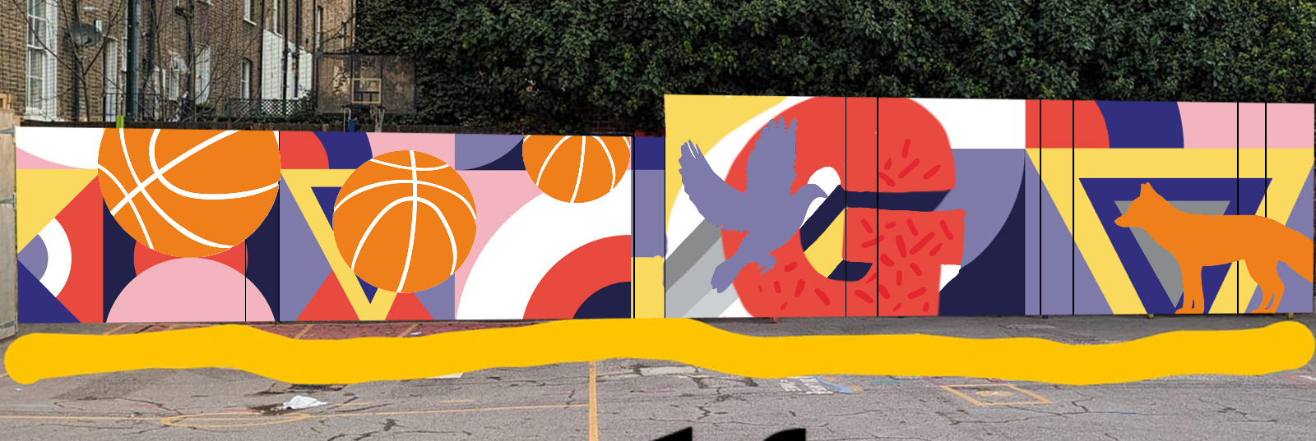
might need a bit more green and blue and rounder edges but agreed with design in general/agreed to go ahead with it. (Veronika)

> LIBRARY MOVE
Bookshelves for novels have been ordered but they are taking weeks to be delivered. As soon as they have arrived and Billy’s fixed them to the wall we can move on with this Project. (Lea)

> BLUE CONTAINER
School worried about safegarding as can’t see entrance and want to move container to along the library wall. Billy getting a quote for that. But that would break the layout of the courtyard and require to split the decking. Worth looking into buying another gate to secure the area so kids can’t access behind container at playtime?
Agreed not good idea to move container, nice space to play with tree to provide shade. We will look into contributing for a better gate and entrance to school. Possibly hiding the bins too in an enclosed area.

> NURSERY/RECEPTION REFURB (£3,000 allocated)
Siobhan to confirm. To be spent on both inside (kitchen arch) and outside (replacing sheds).
Volunteers needed to jetwash and paint the back wall, paint the wooden house etc
Waiting on what the early year will want to spend the money on
Waiting on school to confirm

> GARDEN
Volunteers needed to help Ruthie, Nicola and Léa. Garden sheds, painting, music and water walls. (£1,500 allocated). Book some dates in the calendar for volunteer days?
Nicola and Ruth will order stuff – dates tba

> COMMUNICATION/WEBSITE
Not sure what where the results of the survey?
Ian and Nicola had meeting. There will be more project work to see what needs addressing as a result from feedback. Ian will feed back to Neela.

4. NEXT’S YEARS PROJECTS

> GARDEN PLAY STRUCTURE
We’d like to add a play structure/tree house in the garden near the mud kitchen area.
Have been in touch with Lizzy Fleming <lizzy@madefromscratchltd.co.uk> who did the KS1 play structure. Waiting to hear back but would be good to decide a budget for this. What can be done in the garden? new structure?
Happy to have this as our next big project but costing will be min of £ 20-35K Nicola/Gill/Lea will look into it. What companies, what are the costs

> SHADING PLAYGROUNDS
Shades in KS2. Need to find a way to introduce shades, awnings etc.
Trees in KS1. Need to find a contractor to dig holes, and 3 trees from a local nursery. Planting season around October. Trees recommended by Hackney’s Streetscene Arboricultural Officer raffe.ross-pearce@hackney.gov.uk. ‘I would probably opt for something like a Silver Birch, Field Maple and Scots Pine, three native British trees that can handle the Hackney climate well.’ A "standard" size tree and above would be suitable. These tend to be about 3-4m tall, with a stem diameter of 4 - 6cm. Planted with two stakes, tree ties and a protective guard, they should be sturdy enough to withstand children.
Longterm project, need to look for grants etc - tba

> HALL UPDATE
Big Grasmere sign or mural? Children working with Toby March Creative? (Jenny)
Do we want a mural, or kids contributions? Values will change? tba

> BUILDING LINKS WITH LOCAL COMMUNITY
Grasmere book of recommendations? Little Blue Book with some sponsored entries and quotes and drawings from children. Plumbers, Playgrounds, Restaurants, Shops, Markets, Sports class, Music teachers, Builders, Entertainers, etc.- tba

> COOKBOOK? Might be too much work? Not appropriate for current climate with costs of living go up? – perhaps later in the year, in September - tba

5. DATE OF NEXT MEETING
– Friday 9am 30.06.2023

